Cross- Tabulation Revenue Matrix (Channel Vs Device)
This Query performs a matrix calculation (pivot table) using conditional aggregation (SUM (CASE, WHEN…)). It maps how much revenue each marketing channel generated across the three distinct device type (Desktop, Mobile, Tablet).

QUERY-;

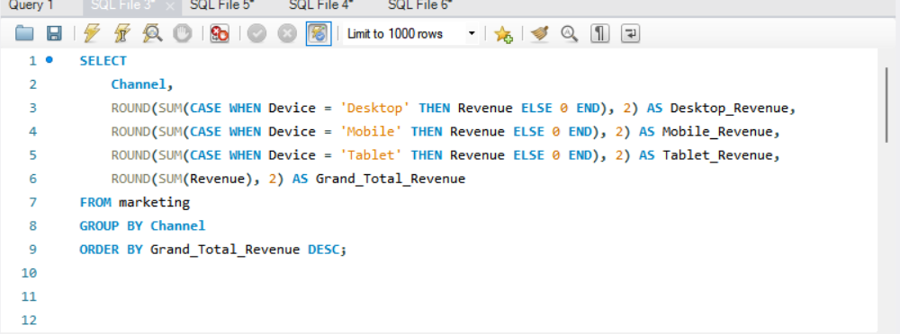

SOLUTION-;

